Concepción Ardon

CS-340

07/10/2022

2-5 Milestone: Project Proposal

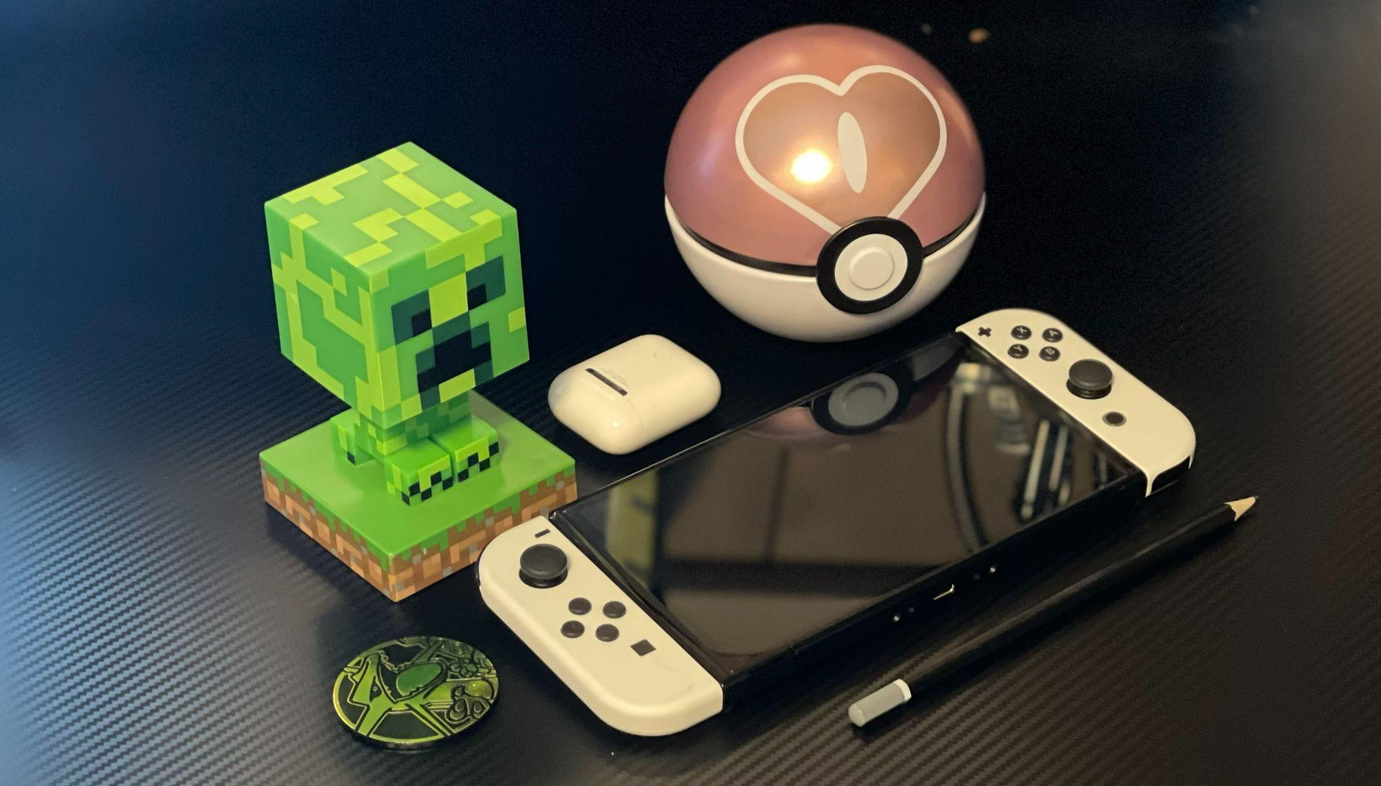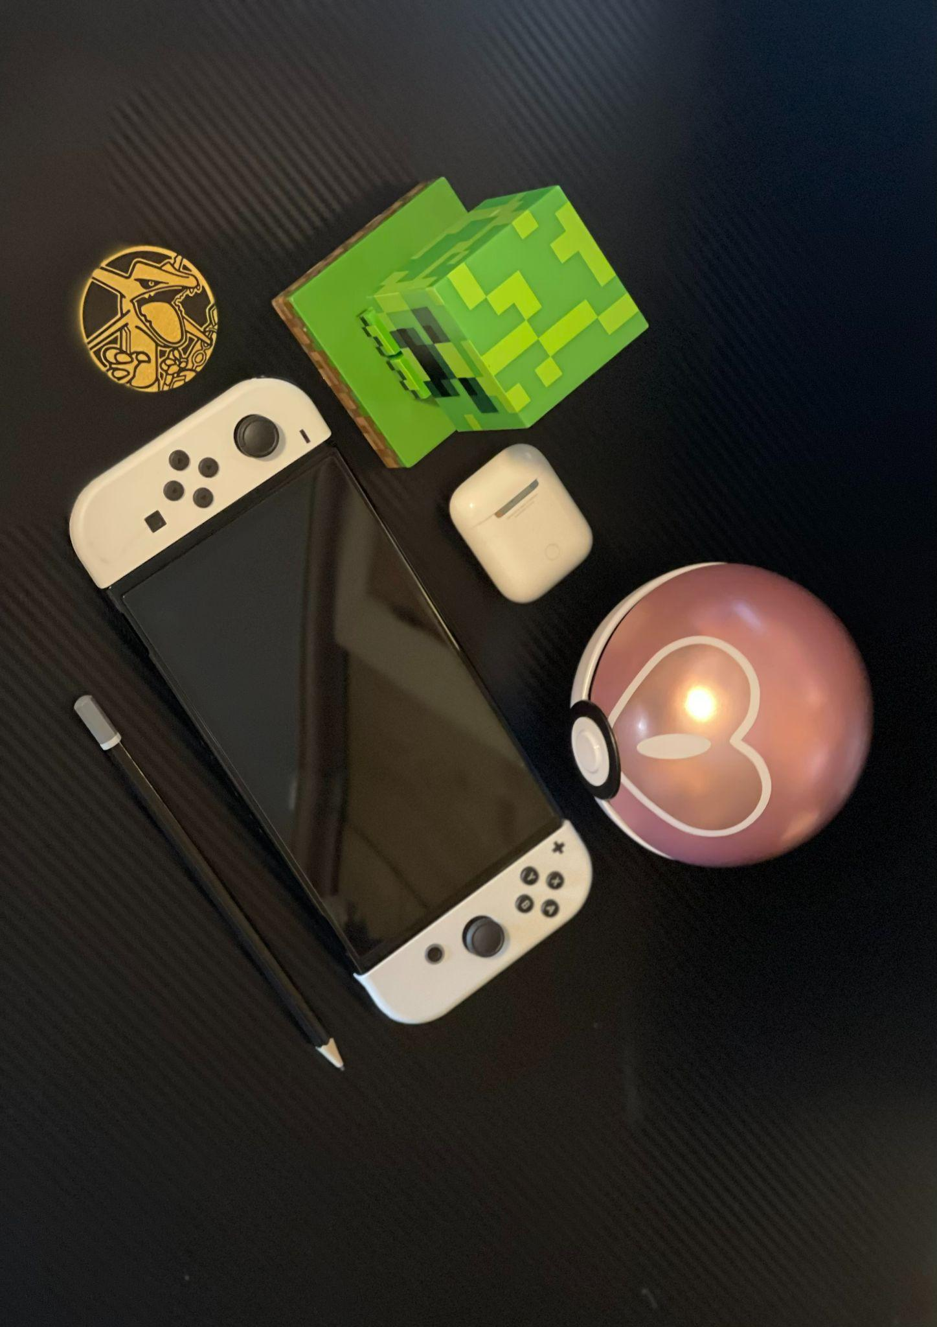

I will be recreating everything in the picture above. The background is plane shape. I will recreate the Minecraft creeper character with cubes because it is mostly made up of cubes. The Apple AirPods will be recreated with a cube along with a plane rectangle and circle for the opening and the button. The Pokeball will be recreated with a sphere and the center opening part with a torus and a sphere to give it that 3d button look. The coin will be created with a sphere if possible to give it that layer, but if not a plane circle. The Nintendo Switch will be recreated with a cube to give it that 3D look. For the round buttons I will use spheres since they pop out and for the square button on the left, a plane will be used. Planes will be used for the minus and plus buttons at the right and left top parts of the gaming system. For the analog sticks, I will use a torus to create that popping-out view. For the pencil, I will use a cylinder to give that long 3D view, and for the tip a pyramid to give that pointy 3D view. By following these steps, I hope to be able to create that image.